**Summary of Unet model building:**

What is Unet Architecture?

**UNet** is a convolutional neural network architecture that expanded with few changes in the CNN architecture. It was invented to deal with biomedical images where the target is not only to classify whether there is an infection or not but also to identify the area of infection.

The Image shows a typical architecture of the UNET model.

The advantage of this architecture is

1. Input image size and output size of the model will be same
2. Reduced number of computations

Basically the model follows a **“U”** shaped pattern where the input on the left hand side is first downsampled by decreasing the length and width of the image and increasing the depth making it a low resolution image, then upsample it to bring back the image to the same dimensions as input.

For our model the input size will be 128x128x3

We downsample it till 8x8x64 using keras api **conv2d and maxpooling2d**

Updample till 128x128x3

The upsample is done using the special keras api **conv2d_transpose**

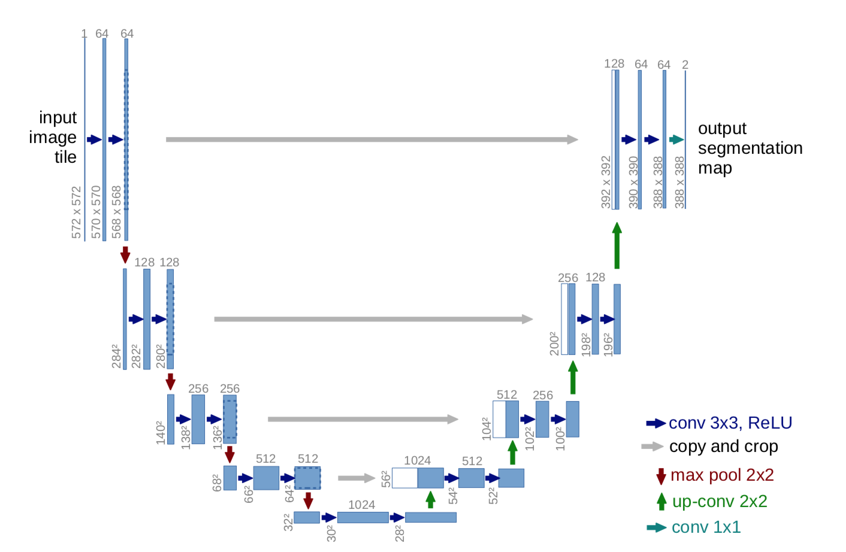

 

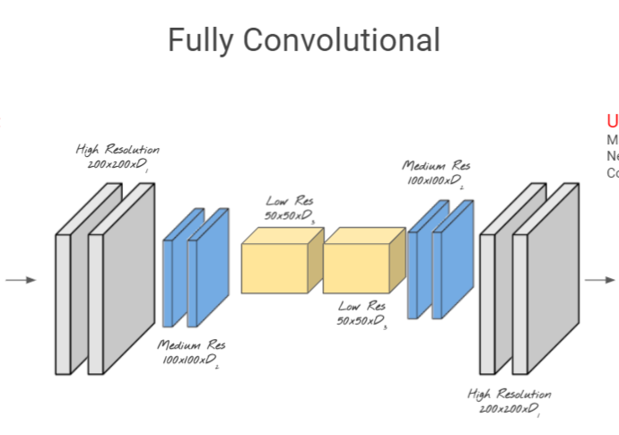

**INPUT:**

* The Input for our model will be an image array of 128x128x3

**Output:**

* Same as for Our vgg model

**Loss Function:**

* Same as for Our vgg model

**Metrics:**

* Same as for Our vgg model

**Train and Validation sets:**

* Same as for Our vgg model

**Image Augmentation:**

* Same as for Our vgg model

**Model Summary:**

**From the summary we can see it has only 2 million weights compared to 50 million weights in VGG model**

Model: "model"

__________________________________________________________________________________________________

Layer (type) Output Shape Param # Connected to

==================================================================================================

input_img (InputLayer) [(None, 128, 128, 3) 0

__________________________________________________________________________________________________

conv2d (Conv2D) (None, 128, 128, 16) 448 input_img[0][0]

__________________________________________________________________________________________________

batch_normalization (BatchNorma (None, 128, 128, 16) 64 conv2d[0][0]

__________________________________________________________________________________________________

activation (Activation) (None, 128, 128, 16) 0 batch_normalization[0][0]

__________________________________________________________________________________________________

conv2d_1 (Conv2D) (None, 128, 128, 16) 2320 activation[0][0]

__________________________________________________________________________________________________

batch_normalization_1 (BatchNor (None, 128, 128, 16) 64 conv2d_1[0][0]

__________________________________________________________________________________________________

activation_1 (Activation) (None, 128, 128, 16) 0 batch_normalization_1[0][0]

__________________________________________________________________________________________________

max_pooling2d (MaxPooling2D) (None, 64, 64, 16) 0 activation_1[0][0]

__________________________________________________________________________________________________

dropout (Dropout) (None, 64, 64, 16) 0 max_pooling2d[0][0]

__________________________________________________________________________________________________

conv2d_2 (Conv2D) (None, 64, 64, 32) 4640 dropout[0][0]

__________________________________________________________________________________________________

batch_normalization_2 (BatchNor (None, 64, 64, 32) 128 conv2d_2[0][0]

__________________________________________________________________________________________________

activation_2 (Activation) (None, 64, 64, 32) 0 batch_normalization_2[0][0]

__________________________________________________________________________________________________

conv2d_3 (Conv2D) (None, 64, 64, 32) 9248 activation_2[0][0]

__________________________________________________________________________________________________

batch_normalization_3 (BatchNor (None, 64, 64, 32) 128 conv2d_3[0][0]

__________________________________________________________________________________________________

activation_3 (Activation) (None, 64, 64, 32) 0 batch_normalization_3[0][0]

__________________________________________________________________________________________________

max_pooling2d_1 (MaxPooling2D) (None, 32, 32, 32) 0 activation_3[0][0]

__________________________________________________________________________________________________

dropout_1 (Dropout) (None, 32, 32, 32) 0 max_pooling2d_1[0][0]

__________________________________________________________________________________________________

conv2d_4 (Conv2D) (None, 32, 32, 64) 18496 dropout_1[0][0]

__________________________________________________________________________________________________

batch_normalization_4 (BatchNor (None, 32, 32, 64) 256 conv2d_4[0][0]

__________________________________________________________________________________________________

activation_4 (Activation) (None, 32, 32, 64) 0 batch_normalization_4[0][0]

__________________________________________________________________________________________________

conv2d_5 (Conv2D) (None, 32, 32, 64) 36928 activation_4[0][0]

__________________________________________________________________________________________________

batch_normalization_5 (BatchNor (None, 32, 32, 64) 256 conv2d_5[0][0]

__________________________________________________________________________________________________

activation_5 (Activation) (None, 32, 32, 64) 0 batch_normalization_5[0][0]

__________________________________________________________________________________________________

max_pooling2d_2 (MaxPooling2D) (None, 16, 16, 64) 0 activation_5[0][0]

__________________________________________________________________________________________________

dropout_2 (Dropout) (None, 16, 16, 64) 0 max_pooling2d_2[0][0]

__________________________________________________________________________________________________

conv2d_6 (Conv2D) (None, 16, 16, 128) 73856 dropout_2[0][0]

__________________________________________________________________________________________________

batch_normalization_6 (BatchNor (None, 16, 16, 128) 512 conv2d_6[0][0]

__________________________________________________________________________________________________

activation_6 (Activation) (None, 16, 16, 128) 0 batch_normalization_6[0][0]

__________________________________________________________________________________________________

conv2d_7 (Conv2D) (None, 16, 16, 128) 147584 activation_6[0][0]

__________________________________________________________________________________________________

batch_normalization_7 (BatchNor (None, 16, 16, 128) 512 conv2d_7[0][0]

__________________________________________________________________________________________________

activation_7 (Activation) (None, 16, 16, 128) 0 batch_normalization_7[0][0]

__________________________________________________________________________________________________

max_pooling2d_3 (MaxPooling2D) (None, 8, 8, 128) 0 activation_7[0][0]

__________________________________________________________________________________________________

dropout_3 (Dropout) (None, 8, 8, 128) 0 max_pooling2d_3[0][0]

__________________________________________________________________________________________________

conv2d_8 (Conv2D) (None, 8, 8, 256) 295168 dropout_3[0][0]

__________________________________________________________________________________________________

batch_normalization_8 (BatchNor (None, 8, 8, 256) 1024 conv2d_8[0][0]

__________________________________________________________________________________________________

activation_8 (Activation) (None, 8, 8, 256) 0 batch_normalization_8[0][0]

__________________________________________________________________________________________________

conv2d_9 (Conv2D) (None, 8, 8, 256) 590080 activation_8[0][0]

__________________________________________________________________________________________________

batch_normalization_9 (BatchNor (None, 8, 8, 256) 1024 conv2d_9[0][0]

__________________________________________________________________________________________________

activation_9 (Activation) (None, 8, 8, 256) 0 batch_normalization_9[0][0]

__________________________________________________________________________________________________

conv2d_transpose (Conv2DTranspo (None, 16, 16, 128) 295040 activation_9[0][0]

__________________________________________________________________________________________________

concatenate (Concatenate) (None, 16, 16, 256) 0 conv2d_transpose[0][0]

activation_7[0][0]

__________________________________________________________________________________________________

dropout_4 (Dropout) (None, 16, 16, 256) 0 concatenate[0][0]

__________________________________________________________________________________________________

conv2d_10 (Conv2D) (None, 16, 16, 128) 295040 dropout_4[0][0]

__________________________________________________________________________________________________

batch_normalization_10 (BatchNo (None, 16, 16, 128) 512 conv2d_10[0][0]

__________________________________________________________________________________________________

activation_10 (Activation) (None, 16, 16, 128) 0 batch_normalization_10[0][0]

__________________________________________________________________________________________________

conv2d_11 (Conv2D) (None, 16, 16, 128) 147584 activation_10[0][0]

__________________________________________________________________________________________________

batch_normalization_11 (BatchNo (None, 16, 16, 128) 512 conv2d_11[0][0]

__________________________________________________________________________________________________

activation_11 (Activation) (None, 16, 16, 128) 0 batch_normalization_11[0][0]

__________________________________________________________________________________________________

conv2d_transpose_1 (Conv2DTrans (None, 32, 32, 64) 73792 activation_11[0][0]

__________________________________________________________________________________________________

concatenate_1 (Concatenate) (None, 32, 32, 128) 0 conv2d_transpose_1[0][0]

activation_5[0][0]

__________________________________________________________________________________________________

dropout_5 (Dropout) (None, 32, 32, 128) 0 concatenate_1[0][0]

__________________________________________________________________________________________________

conv2d_12 (Conv2D) (None, 32, 32, 64) 73792 dropout_5[0][0]

__________________________________________________________________________________________________

batch_normalization_12 (BatchNo (None, 32, 32, 64) 256 conv2d_12[0][0]

__________________________________________________________________________________________________

activation_12 (Activation) (None, 32, 32, 64) 0 batch_normalization_12[0][0]

__________________________________________________________________________________________________

conv2d_13 (Conv2D) (None, 32, 32, 64) 36928 activation_12[0][0]

__________________________________________________________________________________________________

batch_normalization_13 (BatchNo (None, 32, 32, 64) 256 conv2d_13[0][0]

__________________________________________________________________________________________________

activation_13 (Activation) (None, 32, 32, 64) 0 batch_normalization_13[0][0]

__________________________________________________________________________________________________

conv2d_transpose_2 (Conv2DTrans (None, 64, 64, 32) 18464 activation_13[0][0]

__________________________________________________________________________________________________

concatenate_2 (Concatenate) (None, 64, 64, 64) 0 conv2d_transpose_2[0][0]

activation_3[0][0]

__________________________________________________________________________________________________

dropout_6 (Dropout) (None, 64, 64, 64) 0 concatenate_2[0][0]

__________________________________________________________________________________________________

conv2d_14 (Conv2D) (None, 64, 64, 32) 18464 dropout_6[0][0]

__________________________________________________________________________________________________

batch_normalization_14 (BatchNo (None, 64, 64, 32) 128 conv2d_14[0][0]

__________________________________________________________________________________________________

activation_14 (Activation) (None, 64, 64, 32) 0 batch_normalization_14[0][0]

__________________________________________________________________________________________________

conv2d_15 (Conv2D) (None, 64, 64, 32) 9248 activation_14[0][0]

__________________________________________________________________________________________________

batch_normalization_15 (BatchNo (None, 64, 64, 32) 128 conv2d_15[0][0]

__________________________________________________________________________________________________

activation_15 (Activation) (None, 64, 64, 32) 0 batch_normalization_15[0][0]

__________________________________________________________________________________________________

conv2d_transpose_3 (Conv2DTrans (None, 128, 128, 16) 4624 activation_15[0][0]

__________________________________________________________________________________________________

concatenate_3 (Concatenate) (None, 128, 128, 32) 0 conv2d_transpose_3[0][0]

activation_1[0][0]

__________________________________________________________________________________________________

dropout_7 (Dropout) (None, 128, 128, 32) 0 concatenate_3[0][0]

__________________________________________________________________________________________________

conv2d_16 (Conv2D) (None, 128, 128, 16) 4624 dropout_7[0][0]

__________________________________________________________________________________________________

batch_normalization_16 (BatchNo (None, 128, 128, 16) 64 conv2d_16[0][0]

__________________________________________________________________________________________________

activation_16 (Activation) (None, 128, 128, 16) 0 batch_normalization_16[0][0]

__________________________________________________________________________________________________

conv2d_17 (Conv2D) (None, 128, 128, 16) 2320 activation_16[0][0]

__________________________________________________________________________________________________

batch_normalization_17 (BatchNo (None, 128, 128, 16) 64 conv2d_17[0][0]

__________________________________________________________________________________________________

activation_17 (Activation) (None, 128, 128, 16) 0 batch_normalization_17[0][0]

__________________________________________________________________________________________________

global_average_pooling2d (Globa (None, 16) 0 activation_17[0][0]

__________________________________________________________________________________________________

class_op (Dense) (None, 1) 17 global_average_pooling2d[0][0]

__________________________________________________________________________________________________

reg_op (Dense) (None, 4) 68 global_average_pooling2d[0][0]

==================================================================================================

Total params: 2,164,661

Trainable params: 2,161,717

Non-trainable params: 2,944

__________________________________________________________________________________________________

**Result**:

* With all these steps we fit the model and ran it for 20 epochs and obtained the below accuracy for classification and regression.
  + Train Iou => 0.28 , Validation Iou => 0.35
  + Train_accuracy => 86% , Validation accuracy => 84%

**Prediction:**